fluorescent light set-ups

Each one of these are different lights ranging from the first one an expensive Amazon purchase to the last one in the greenhouse a shop light Home Depot special.

T-5- 4 bulbs - 4-54 watts 6400K 4-2000 lumens - 2’ long - Amazon $99.19
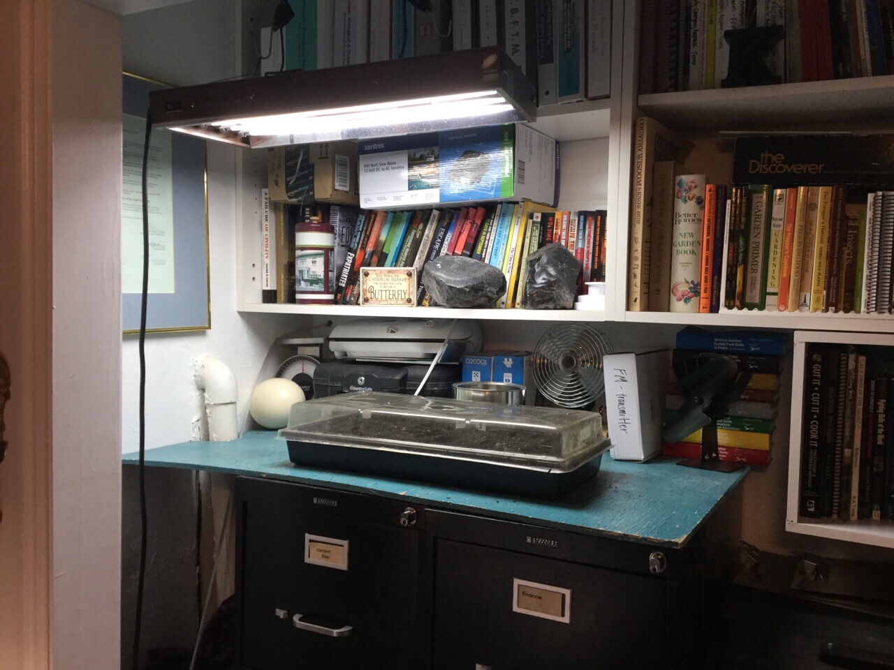
T-12 - 2 bulbs - 2-40 Watts 6500K 2-2000 lumens - 4’ long - Home Depot $23.27
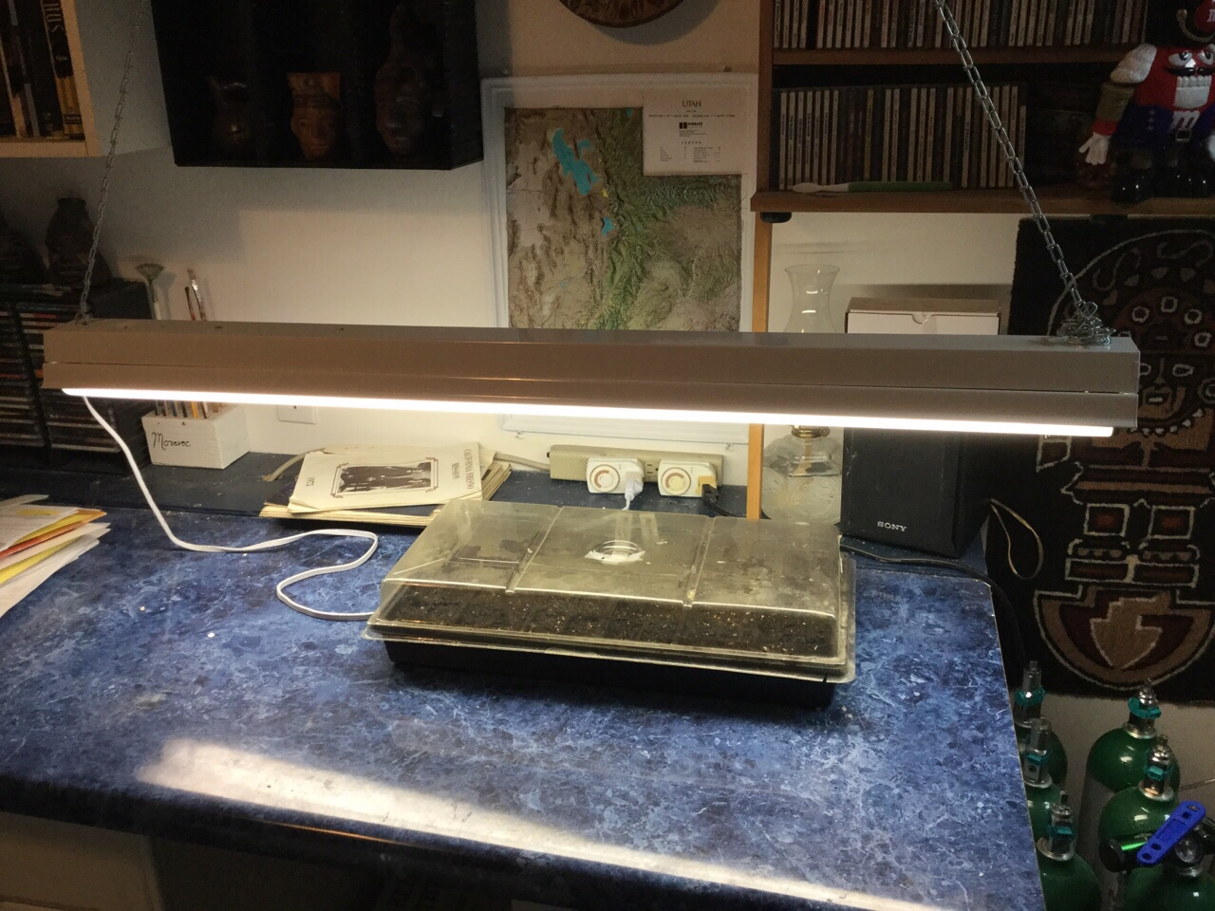
T-5- 4 bulbs - 4-54 watts 6400K 4-2000 lumens - 2’ long - Amazon $99.19
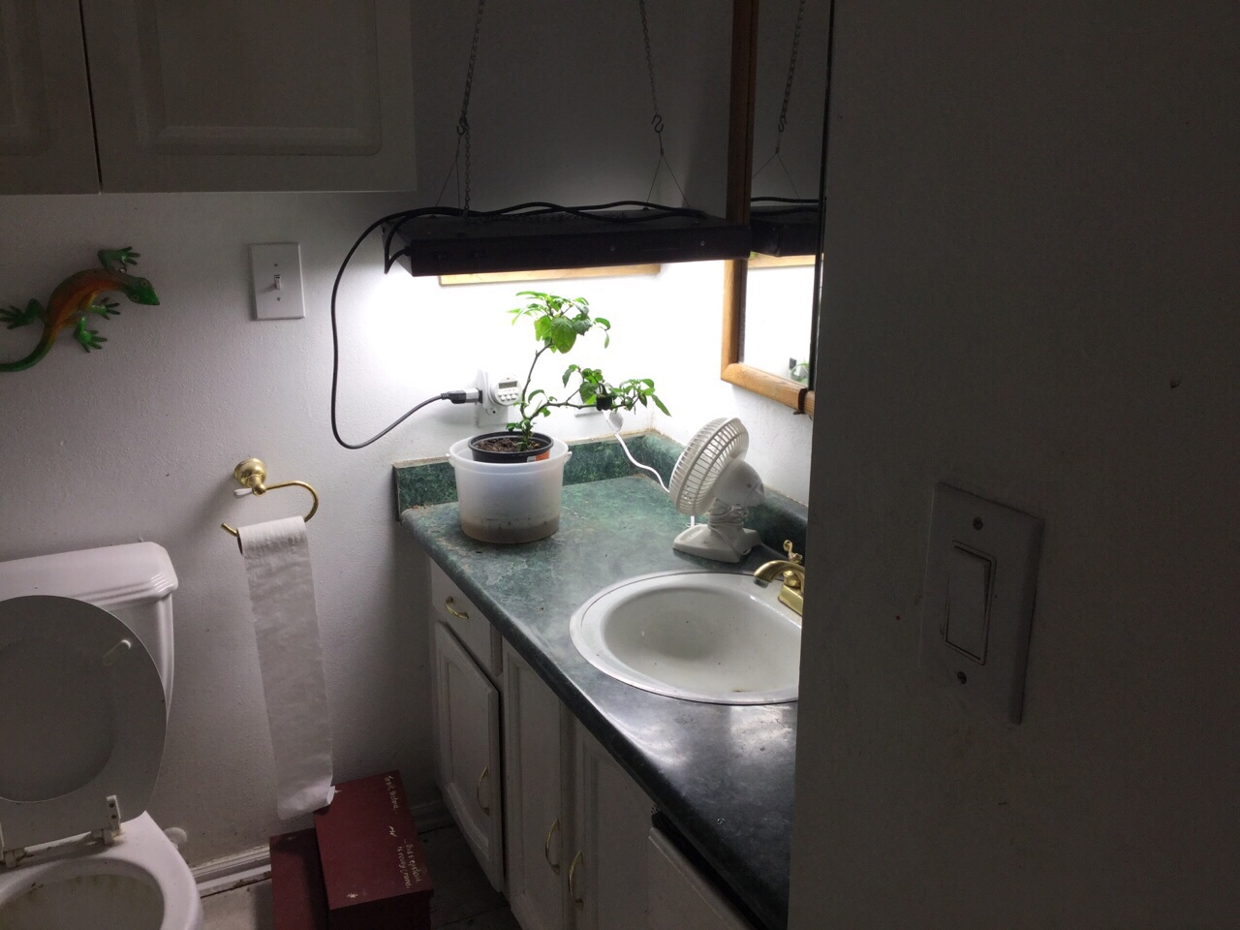
T-5 - 2 bulbs - 2-14 watts 3000K 2-2000 lumens - 22” long - Home Depot $24.97
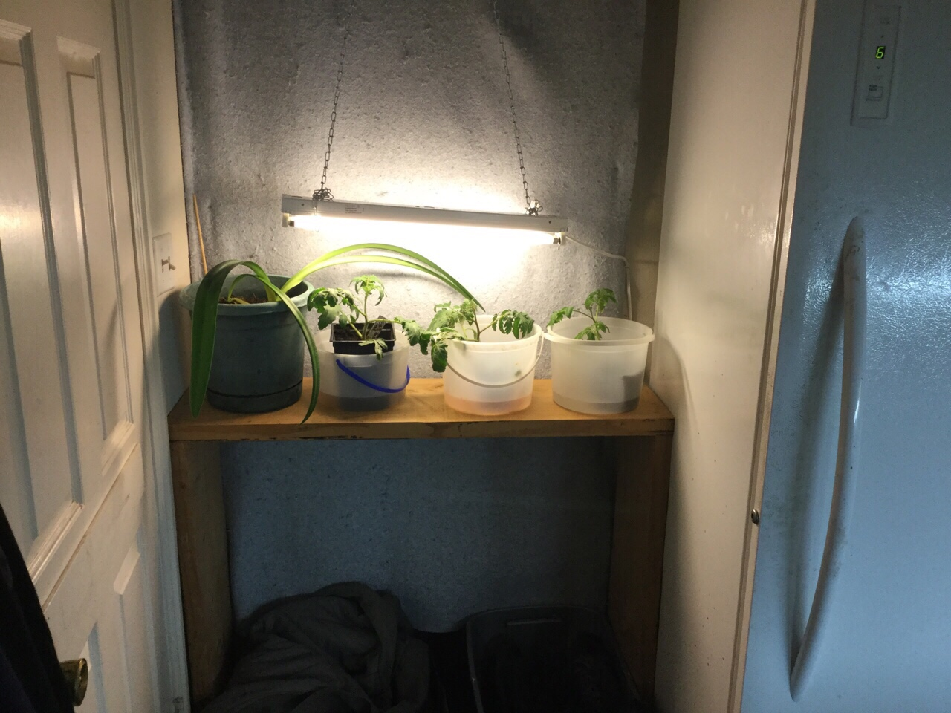
T-8 - 3 bulbs - 3-32 watts 6500K 2-2750 lumens - 4’ long - Home Depot $53.27 each
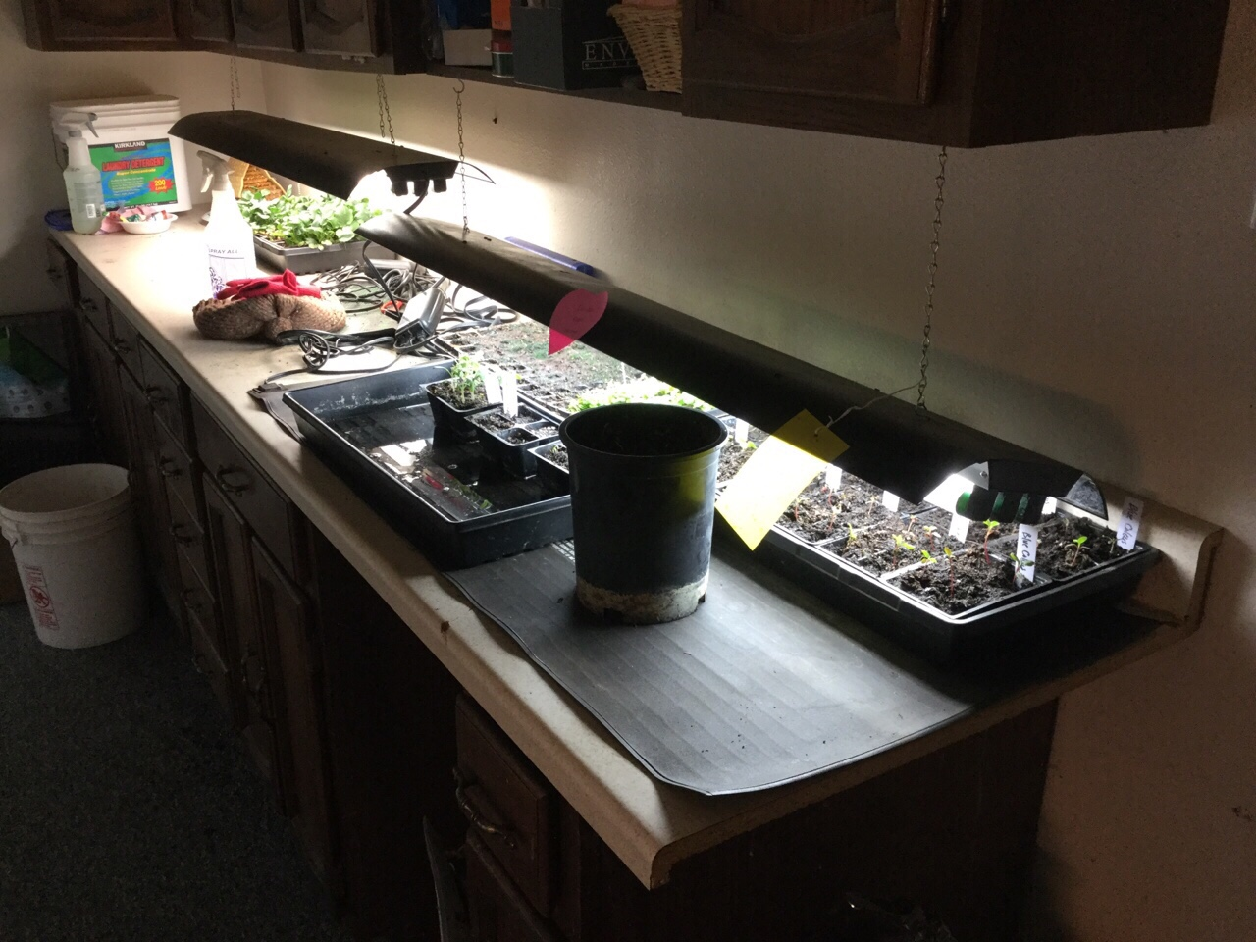
T-5- 4 bulbs - 4-54 watts 6400K 4-2000 lumens - 2’ long - Amazon $99.19
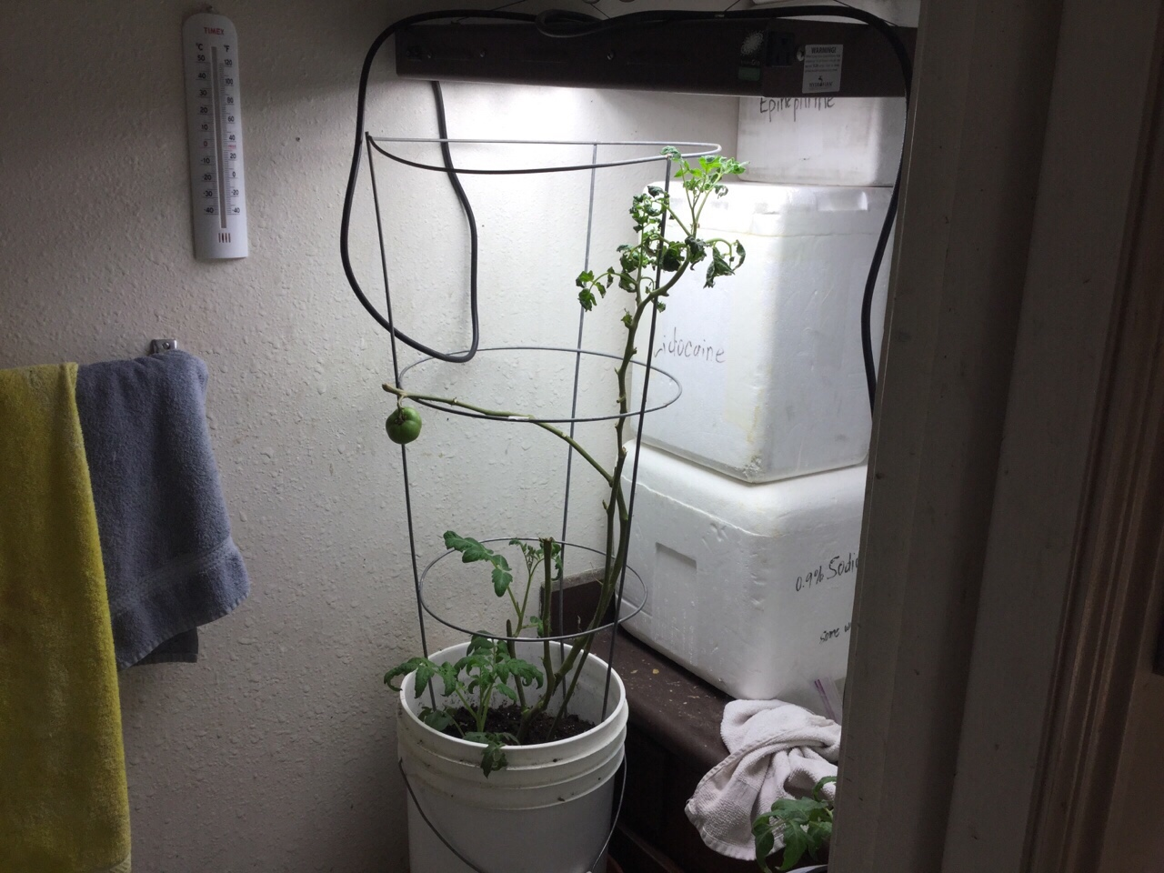
T-12 - 2 bulbs - 2-40 watts 6500K 2-2000 lumens - 4’ long - Home Depot $23.27
