Heat mats
I have multiple of both of these heat mats and have put them to the test over the years. There are actually 4 others I have used that burned out or had other issues that I won’t recommend at all.

This one is the one I really like especially in the 48” x 20” size because it can do 4 trays at one time AND it uses the same amount of electricity as the one below which only does one tray. So if you have the space for it, this is my top recommendation.
https://www.amazon.com/gp/product/B0057A9SF6/ref=oh_aui_search_detailpage?ie=UTF8&psc=1

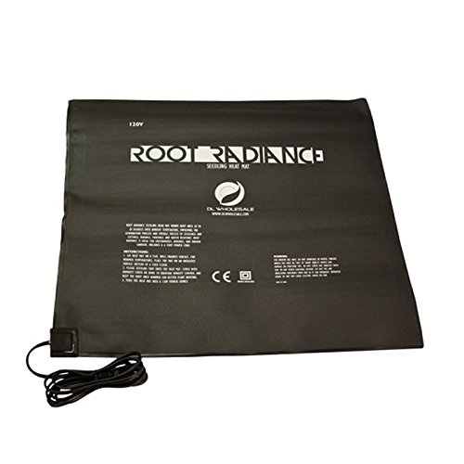

This one is okay but not my top choice. Too small. It can only do one tray.
https://www.amazon.com/gp/product/B0001WV010/ref=oh_aui_search_detailpage?ie=UTF8&psc=1
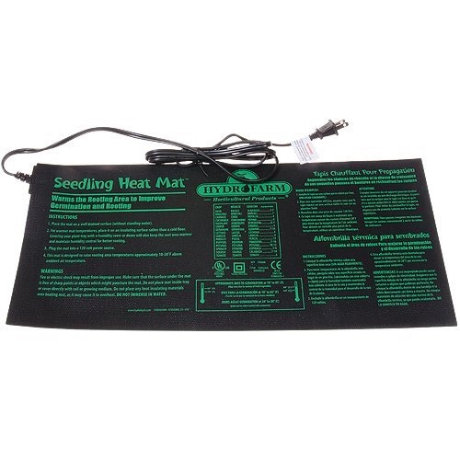
I really suggest also a thermostat control. This is the one I really like.
https://www.amazon.com/gp/product/B000NZZG3S/ref=oh_aui_search_detailpage?ie=UTF8&psc=1

